**PROFESSIONAL PROGRAMMING TRAINING CENTER**



**PROJECT DOCUMENT**

**Project Name: E-BANKING**

Course : Software Testing

Group : 3

Member : Nguyễn Trần Hoài Thương

Huỳnh Thị Hoài Thương

Trainer : Huỳnh Trang

***Danang,***

**PREFACE**

# First of all, we would like to thank all the teachers and staff at the iViettech Professional Programming Training Center for imparting significant knowledge and skills to us during our course. The knowledge we have received allows us to practice effectively, so we are grateful for that.

# More importantly, we would like to convey our deep gratitude to Ms.Trang, our supervisor, who mentored and supported us throughout our course as well as our project by providing us with numerous helpful suggestions. Her guidance has aided our project's success.

# With a student's limited time and experience, this report will inevitably have flaws. We look forward to the teachers' recommendations and comments so that we may have additional opportunities to expand our understanding.

# Finally, we wish all teachers good health and continued success in their noble professions.

# Your sincerely,

Nguyen Tran Hoai Thuong & Huynh Thi Hoai Thuong.**TABLE OF CONTENTS**

**1. Introduction** 3

1.1 Project name: EBanking 3

1.2 Objectives: 3

1. 3 Brief of Requirements: 3

1. 4 Scopes: 4

**2. Planning** 5

2.1 Methods and Technology Selected 5

2.2 Team and Schedule 6

**3. Result Reports**  7

3.1 Test Design 7

3.2 Test Results 8

3.3 Lesson Learn 10

3.3.1 Test Process: 10

3.3.2 Test Level: 11

3.3.3 Test case design techniques: 11

**4. Conclusions and Expand**  12

**5. References**  12

**1****. Introduction**

*1. 1 Project name: EBanking*

*Short description:* E-Banking is an electronic bank system allowing customers to operate basic transactions via the Internet, such as view account information, change password, check balances, transfer money, etc. Besides, the admin can perform the functions of managing customer list, withdrawing money, depositing money, and checking the transaction log by customer or by day.

*1. 2 Objectives:* This document provides more requirement details to develop an e-Banking system. This document can be used for mock projects for software development courses or software testing courses.

*1. 3 Brief of requirements:*

*-* A bank website is a fictitious transaction office but provides readers with necessary information and transactions.

- Object of use: admin, user

- Device: PC, laptop.

|  |  |
| --- | --- |
| **Function** | **Requirement** |
| Register | - Allowing customers to register their account on the Web and then become users  - Only using functions based on their role (user or admin) |
| Login | - Displaying Username, Password textboxes, Captcha and Login button.  - Moving to the Main page if logged in successfully.  - Showing error message if logging in failed |
| Internal Transaction Money | - Allowing users to transfer money to an internal account |
| External Transaction Money | - Allowing user transfer money to an external account |
| History Transaction | - Displaying account list to users if they have more than one account  - Displaying screen for customer choose duration (start date and end date).  - Displaying all transactions in this duration for customer |
| Create account | - Allowing user to create another account number |
| Change password | - Displaying Old password, New password, Retype new password and Login button.  - Updating data successfully if input valid value to all fields  - Showing error message if input invalid value to all fields |
| View personal information | - Showing personal information of user |
| View available balance | - Displaying account list to users if they have more than 1 account.  - Displaying balance of selected account.  - Printing receipt if required. |
| Deposit money | - Allowing admin to deposit money from user’s account  - The available balance is increased |
| Withdraw money | - Allowing admin to withdraw money from user’s account  - The available balance is reduced |
| Print Receipt | - Formating data and display it on printed view.  - Printing to pdf file if user requests. |
| Logout | - Clicking on the Exit menu to logout.  - Moveing to the Login page when logout successfully. |

*1. 4 Scopes:* Internal Transaction, External Transaction, Deposit Money, Withdraw Money, History Transaction

**2. Planning**

***2.1 Methods and Technology selected***

*Black box:*

* Equivalence partitioning: The equivalence partitioning technique takes advantage of the properties of equivalence partitions to reduce the number of test cases we need to write. We need only test one of them as a representative of the partition.
* Boundary value analysis: The error commonly occurs near these boundary values.
* State Transition: involves an analysis of the relationship among the states and the events or actions that cause the transitions from one state to another
* Decision table testing: Present inputs compared to test rules/cases/conditions

*Experience Based Testing*

* Error guessing: Adds another value in identifying and executing test cases that target known or suspected weaknesses or simply address aspects of the application that have been found to be problematic topic in the past.
* Exploratory testing: Discovering unexpected or previously unknown errors that may potentially occur in the future.

***2.2 Team and Schedule***

|  |  |  |  |  |
| --- | --- | --- | --- | --- |
| **Team member** | **Module** | **Role** | **Schedule** | |
| **Start day** | **End Day** |
| **Nguyễn Trần Hoài Thương** | Deposit money | Admin | 17/8 | 24/8 |
| External Transaction | User | 24/8 | 29/8 |
| History Transaction | User | 29/8 | 3/9 |
| **Huỳnh Thị Hoài Thương** | Withdraw money | Admin | 17/8 | 24/8 |
| Internal Transaction | User | 24/8 | 29/8 |
| History Transaction | Admin | 29/8 | 3/9 |

**3. Result Reports**

***3.1 Test Design***

|  |  |  |  |
| --- | --- | --- | --- |
| **Sr.no** | **Module** | **Number of Test Case** | **Description** |
| 1 | Deposit money | Total TC: 46 | PASS: 25  FAIL: 21 |
| 2 | Withdraw money | Total TC: 47 | Pass: 16  Fail: 28  Untest: 0  Block: 3 |
| 3 | Internal Transfer Money | Total TC: 73 | Pass: 48  Fail: 14  Untest: 0  Block: 11 |
| 4 | External Transfer Money | Total TC: 96 | Pass: 56  Fail: 28  Untest: 0  Block: 12 |
| 5 | User - History Transaction | Total TC: 74 | Pass: 44  Fail: 25  Untest: 0  Block: 5 |
| 6 | Admin - History Transaction | Total TC: 91 | Pass: 61  Fail: 26  Untest: 4  Block: 0 |

***3.2 Test results***

|  |  |  |  |
| --- | --- | --- | --- |
| **Sr.no** | **Module** | **Number of major bug** | **Number of minor bug** |
| 1 | Deposit money | High: 1 (Another transaction is made when the user click on reload) | Medium: 2 (An error page, Allows deposit 0 VND)  Low: 16 (Error message) |
| 2 | Withdraw money | High: 1 (Another transaction is made when click [Reload] button on web browser.) | Medium: 3 (Error page, do not reset after a successful transaction)  Low: 16 (Error message, error page, do not reset after a successful transaction, ect.) |
| 3 | Internal Transfer Money | High: 1(Account is not locked when enter wrong OTP 5 times in a row) | Medium: 3 (Allows transfer 0 VND)  Low: 10 (Error message, error page, do not reset after a successful transaction, no margin, not show the default textbox of [Phí], etc.) |
| 4 | External Transfer Money | High: 1 (account is not locked when the user enter incorrect OTP 5 times) | Medium: 16 (An error page, Allows transfer 0 VND, the amount exceeds the prescribed amount)  Low: 9 (Error message, lost transaction information, Not reset data) |
| 5 | User - History Transaction | High: 1 (Transaction history information is displayed incorrectly) | Medium: 2 (An error page)  Low: 13 (Error message, Not reset data of page, Unicode error) |
| 6 | Admin - History Transaction | High: 5 (There is no transaction information when enter the same value to [Từ ngày] and [Đến ngày]) | Low: 14 (Error message, Language is not consistent, currency format error, etc.) |

***3.3 Lesson Learn***

**3.3.1 Test process:**

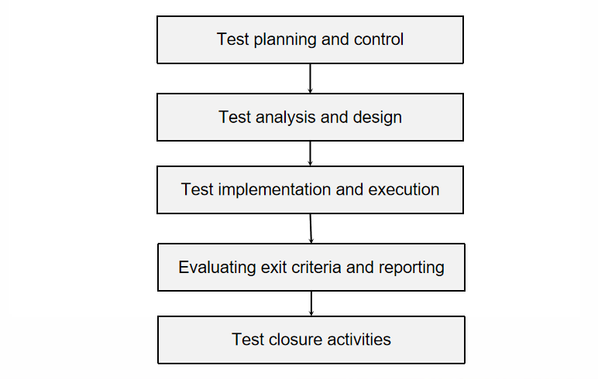

**3.3.2 Test Level:**

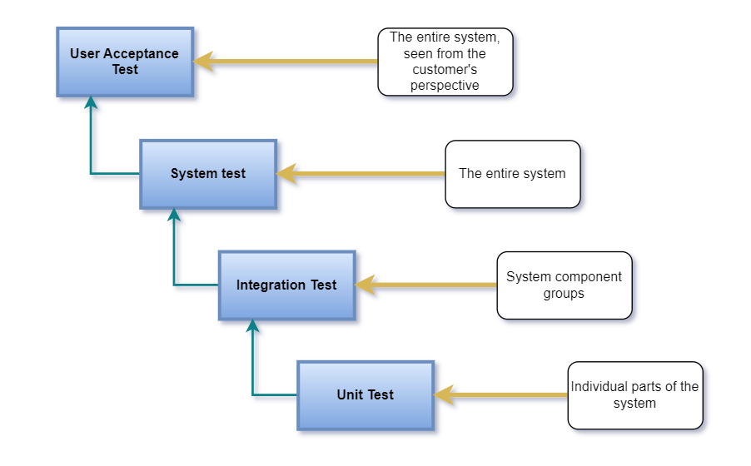

*Unit test:*

* Implementer: Usually the developer

*Integration test:*

* Implementer: tester or developer (depending on the model or scale of the company/project required)

*System test:*

* Implementer: Tester

*User acceptance test:*

* Implementer: Tester, Customer or 3rd party

**3.3.3 Test case design techniques:**

* Black-box techniques: Equivalence Partitioning, Boundary Value Analysis, Decision Table Testing, State Transition Testing, Use Case Testing
* White-box techniques: Statement testing and coverage, Paths through a program, Decision testing and coverage
* Ad hoc techniques: Error guessing, Exploratory Testing, Checklist-based Testing

**4. Conclusions and expand**

Advantages:

* The bank has developed convenient online transaction applications and systems for customers
* Fast transaction processing time
* Easy to use for users

Disadvantages:

* Transaction fees are too high
* The admin's withdrawal and deposit service still has some serious errors
* Checking the transaction log has many errors
* There is no Captcha and captcha textbox when logging in
* The system should verify the phone number when registering an account.

Suggestion:

* Transaction history should display transaction content

**5. References**

SOFTWARE TESTING An ISTQB-BCS Certified Tester Foundation guide Fourth edition

-END-